**Let’s Do the Math to“Hack our Snack”!**

*When we eat a snack, where does the energy go? How much can we use?*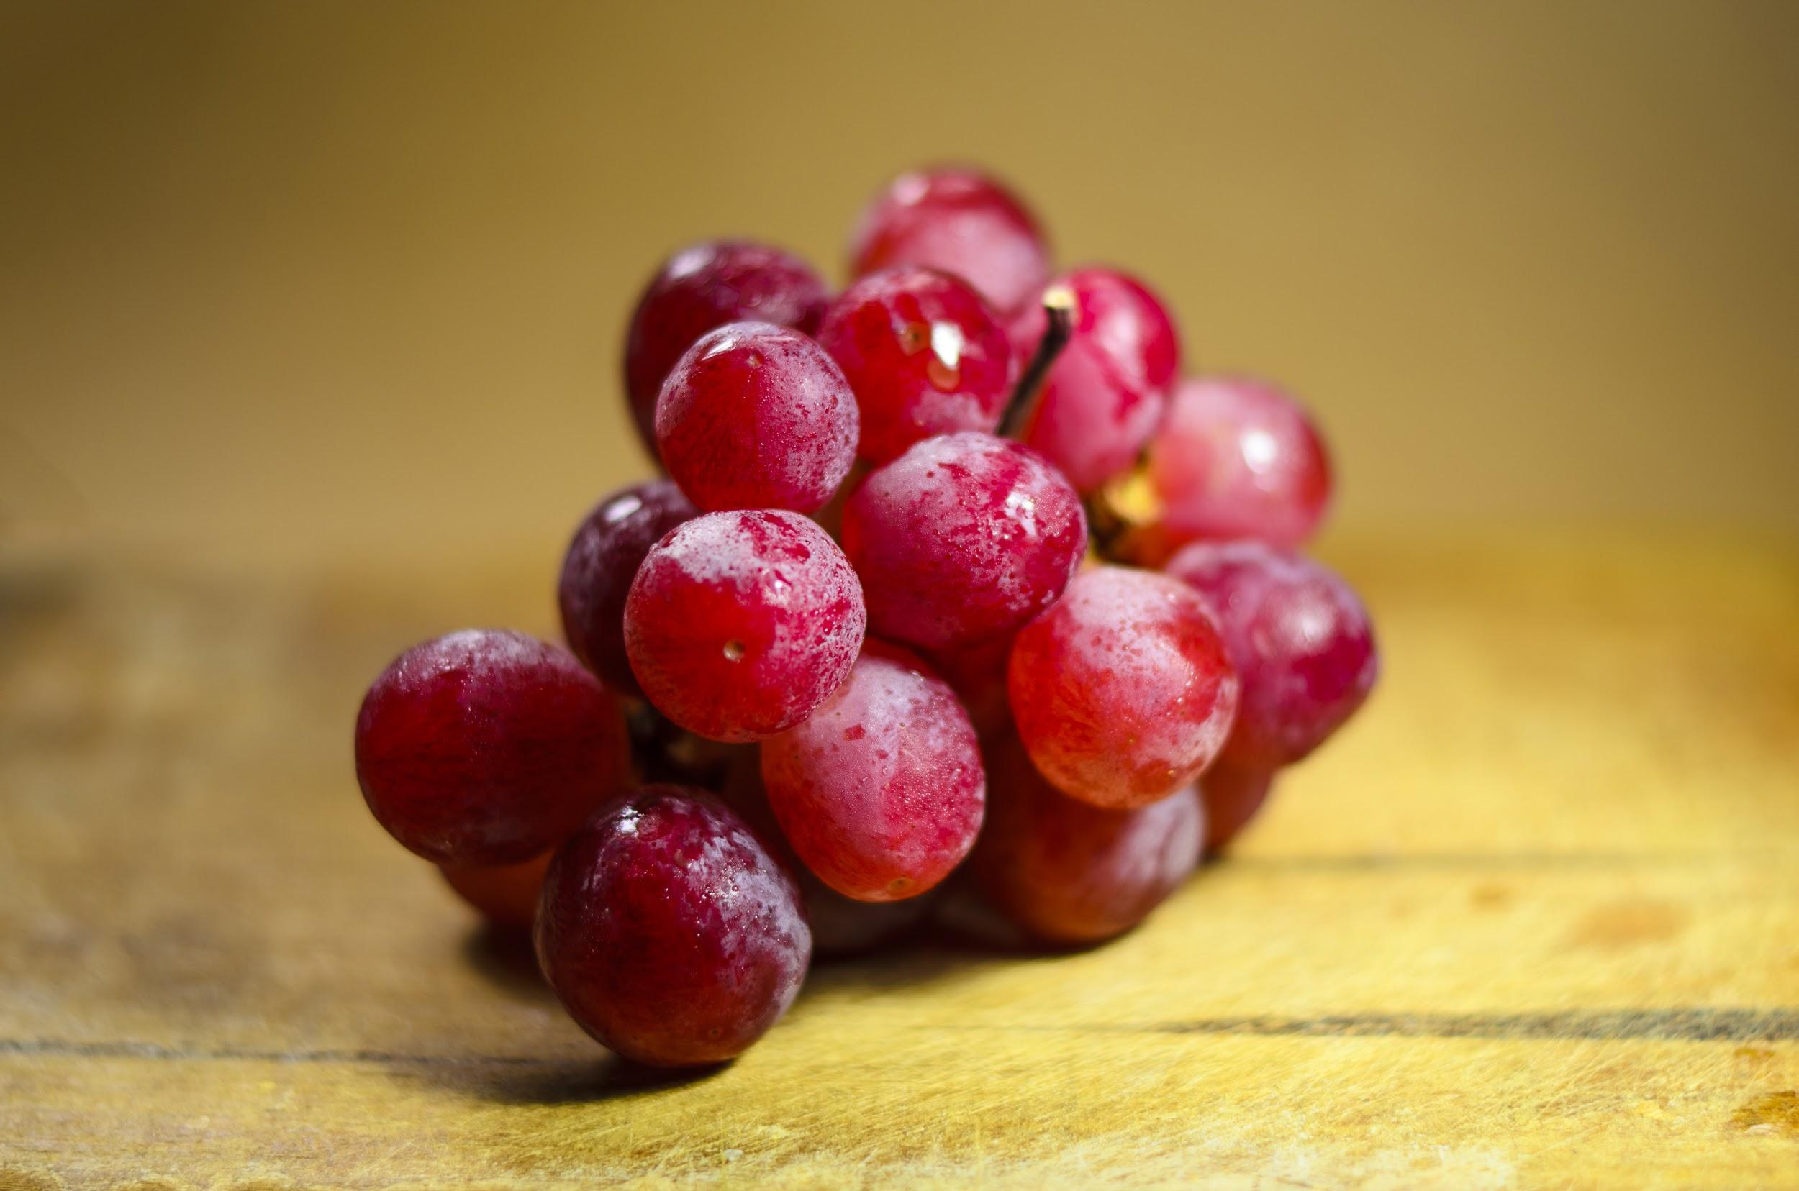



**Eat food Energy used to digest food Energy available to use**

200 calories of grapes → 200 calories

-20 calories used in digestion

180 calories available

**-** 40 calories/ hour ←- **Energy used to lay in bed for 1 hour**

60 calories to use -----> 60 calories

